**WEBSITE IDEA FOR THE SALE OF SCHOOL ITEMS**

**1. Introduction**

**Website idea**

What is required is to have a website, in which you can promote and sell products such as school supplies made with distinctive materials and at a lower cost in the province of Arequipa, both for natural and legal persons.

**The values ​​/ benefits (tangible and intangible)**

This page will be one of the main sources of income in the organization, since they can be sold from this site, it is also with the purpose of starting and exponentially increasing sales in this company that is just being formed, another reason is to speed up the process of selling these items.

**2. List of expected characteristics**

Expected functions:

* List and visualize the available products that are being sold in the company: this will allow customers to sketch the product catalog
* Allow the sale of products for both individuals and legal entities: this with the aim of reaching more customers and streamlining sales.
* Allow to give greater knowledge about the objectives of the company: this with the aim of giving greater security on the part of the company to customers
* Allow to give knowledge about the company's contacts: this with the aim that if some clients want to contact the company personally

**3. Market study**

**Tai Loy:** It is a store dedicated to the sale of various items, ranging from Home to Groceries, this store also includes the sale of school supplies.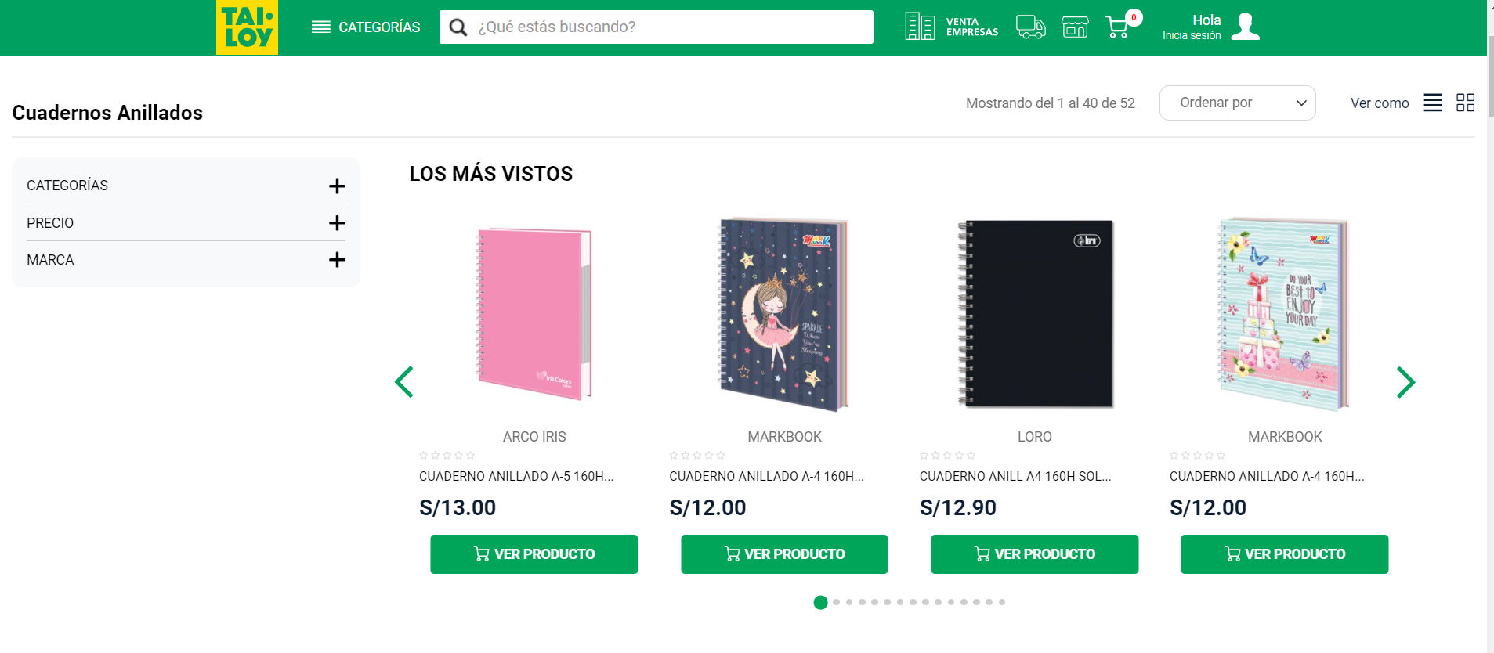

**Stanford:** It is a company that sells school supplies, its main product sold are notebooks, its website does not have e-commerce capacity, but the catalog of notebooks can be viewed.

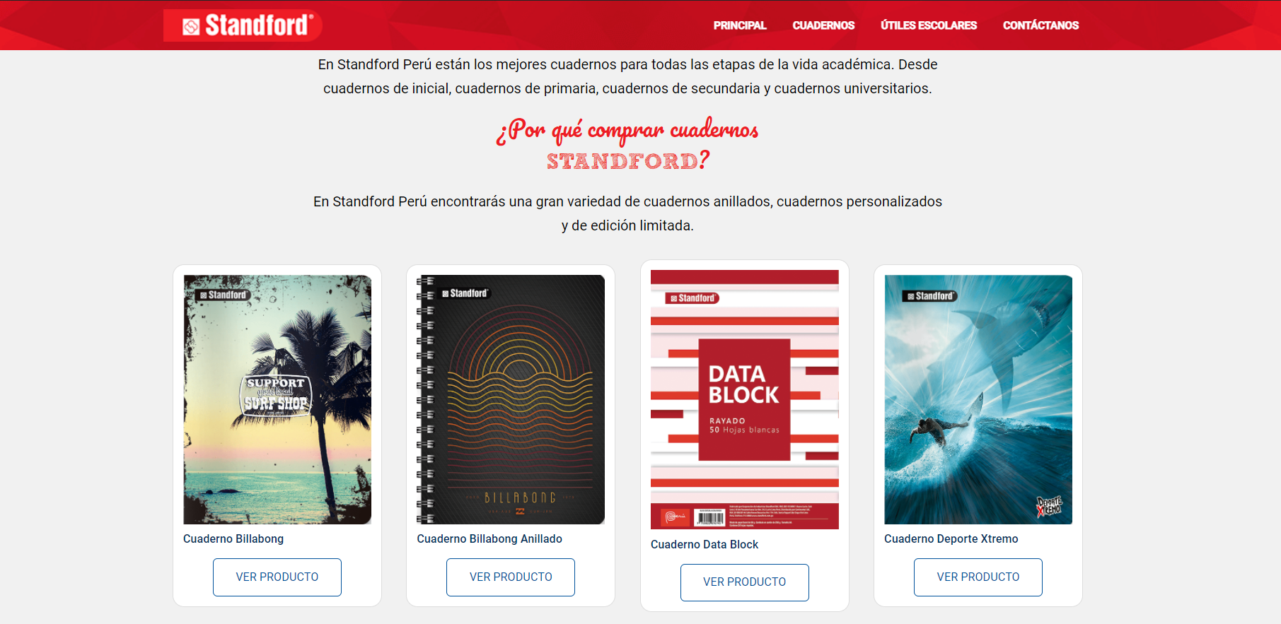

**La Papelerie:** It is a company that sells school supplies, this company focuses on the design of its articles.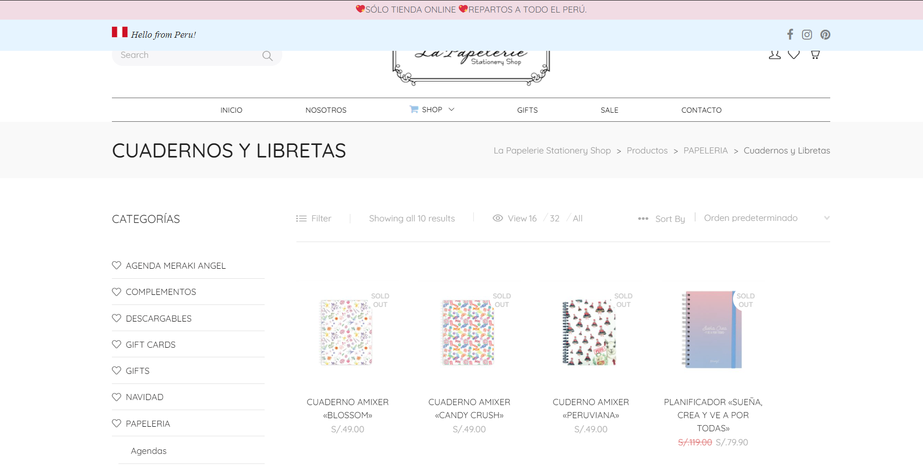

**Utilex:** It is a company that sells school supplies, ranging from technology to desks.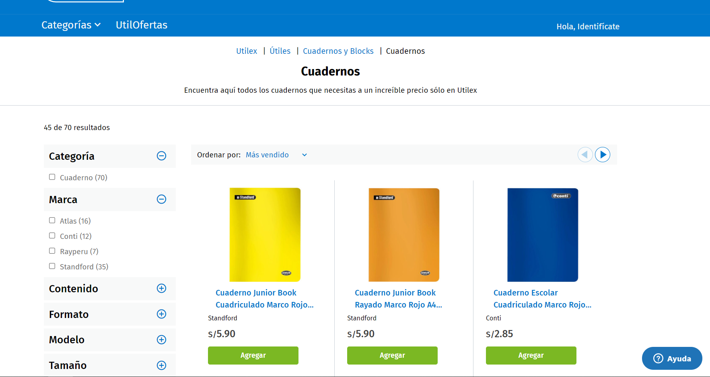

**Lapapela:** specialized in articles for artists, designers, architects, engineers and amateurs, this includes sale of notebooks.

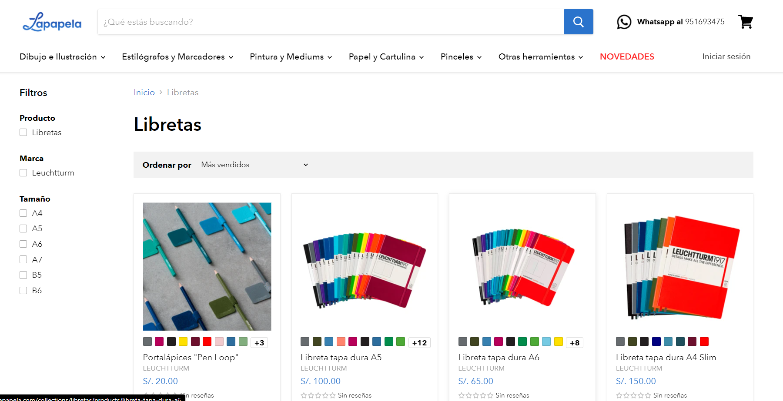

Comparison table

|  |  |  |  |  |  |
| --- | --- | --- | --- | --- | --- |
| **FEATURES / WEB PAGE** | **Tai Loy** | **Stanford** | **La Papelerie** | **Utilex** | **Lapapela** |
| **Product catalog** | X | X | X | X | X |
| **Online sales differentiated by types of customers** |  |  |  |  |  |
| **Company personal information** | X | X | X | X | X |
| **Company contact information** | X | X | X | X | X |

**4. References**

* <https://www.tailoy.com.pe/escolar/cuadernos-y-blocks/cuadernos-anillados.html>
* <https://standford.pe/cuadernos/>
* <https://www.lapapelerie.com/categoria-producto/papeleria/notebooks/>
* <https://utilex.pe/cuadernos>
* <https://lapapela.com/collections/libretas>